**ESC 101F 2020 – Engineering Science Praxis I**

University of Toronto

Faculty of Applied Science and Engineering

Final Examination

December 11, 2020

**ANSWER BOOKLET**

**How to use this answer booklet:**

* If you have not already done so, rename this exam file as *utorid*--final.docx  (where *utorid* is replaced with your UTORid) and save it to your computer.
* All answers should be inserted directly into this document, under the appropriate question heading.
* Each question is designed to be answered starting on a new page. Do not change this.
* Make sure that your answer for each question is above the horizontal line. The horizontal line will move as you type.
* Save this file as a PDF named *utorid--final.pdf* when you are done. Upload it to the Final Exam Assignment before the end of your exam time. You do not need to upload the exam questions sheet.
* **Save this document regularly to ensure no loss of data.**

**Student Information**

* Fill in your own information below

**Name: __________Regis Zhao_______________**

**Student Number: ________1007070660_______________**

**UTORid: __________zhaoregi__________________**

**Textblock:** (highlight the one you are writing in)

* International: 7:00am-10:00am EST
* Toronto-ish: 9:00am-12:00pm EST
* Western: 10:00am-1:00pm EST

**1. REQUIREMENTS DEVELOPMENT QUESTION**

1. The design opportunity is developing a shoe that is suitable for individuals working at post-secondary institution labs and workplaces.

|  |  |  |
| --- | --- | --- |
| **DfX** | **Associated Objective** | **Justification** |
| **1. Safety** | Comply with the U of T biosafety rules and standard for foot protection in U of T workplaces. | Safety is an important value for these stakeholders because, as stated by the stakeholders, they all work in a lab environment where chemicals could spill and machinery could fall, which could cause harm to the worker.  Complying with the U of T biosafety standards for foot protection will ensure the stakeholder’s safety in most post-secondary workplaces (even though the scope of the U of T standards only apply to workers “within a University of Toronto workplace”) because of the similarity between most university labs, as well as the fact that the standards were based on CSA standards, which are likely used by most Canadian universities. |
| **2. Durability** | Maximize the upper sole adhesion of the shoe. | For all four stakeholders, they state that shoe will be heavily used and worn often. Frequent usage leads to degradation of the shoe. Therefore it is important to design for durability to ensure that the shoe can withstand heavy usage. By maximizing the upper sole adhesion, it will require more force to damage/make the shoe fall apart[2], and therefore the shoe will stay intact for a longer period of time under heavy usage. |
| **3. Comfort** | Maximize how well the shoe length matches the user’s foot. | The comfort of the shoe is important because stakeholders 2, 3, and 4 have all stated that they will be standing/walking around in the shoes for long periods of time every day (e.g. from stakeholder 3: “comfortable enough to stand in for long periods of time (several hours)”).  Maximizing how well the shoe length matches the user’s foot will maximize comfort because it will be the most suitably sized shoe for the user[7]. |
| **4. Convenience** | Maximize the shoe’s water resistance. | All stakeholders have identified convenience in cleaning the shoe as a desired quality for the shoe, therefore designing for convenience is important. As stated by the stakeholders, maximizing water resistance, will make it easier for the stakeholders to clean off chemicals from the shoe or just in general. This objective will also help design for comfort as the stakeholders mention not getting their feet wet on rainy days is a desirable quality. |

1. Regarding the upper sole adhesion of the shoe: a greater upper sole adhesion is better, less is worse. This is because the objective aims to require a *greater* amount of force to damage the shoe, in turn making it more difficult to damage the shoe under heavy usage.
2. For the safety objective: the shoe *must* comply with all of the applicable rules/standards set by the University of Toronto. They have been made standards based on the CSA, and therefore are reliable standards to follow to ensure safety of the worker’s feet – anything less may result in injury.

**2. CONVERGING SPRINT ANALYSIS QUESTION**

INTRODUCTION

The purpose of this Sprint Analysis is to reflect on my involvement in the converging process of engineering design. My team and I, a group of Praxis students, were tasked with making a recommendation for a music stand design for outdoor performers, given a set of potential candidates. This document outlines how my team’s convergence process led to further divergence and the resulting insights I have gained on the convergence process.

PROMOTING DIVERGENCE THROUGH CONVERGENCE

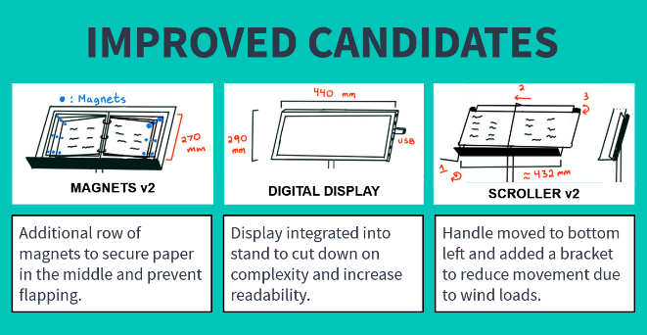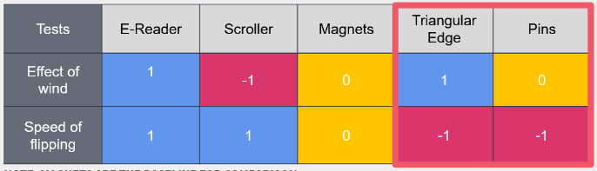In the process of determining a music stand design to recommend for outdoor performers, my team performed multiple rounds of converging before we arrived at our final design concept. We first performed a quick preliminary round of converging by tournament selection from the initial given 12 candidates. Testing the remaining candidates and placing the results in a Pugh chart, we eliminated two designs, but found that two of the remaining designs, when evaluated holistically, seemed like equally good candidates for the final design. Even though the third remaining design performed better than these two designs as a whole, my team and I encouraged each other to keep exploring the different approaches to see if there was greater potential within them. This roadblock in the convergence process, where two designs performed similarly, promoted another round of diverging, where we used techniques similar to SCAMPER, trying to improve on certain aspects of each design while keeping the overall approach.

INSIGHTS GAINED ABOUT PROCESS/TOOLS AND MODELS

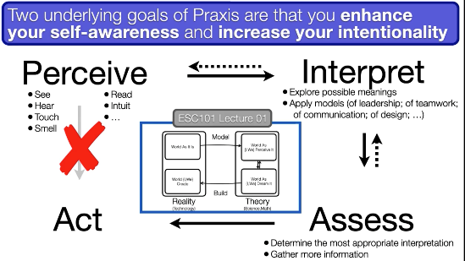The roadblock my team encountered in the converging process allowed me to experience the non-linear and iterative process of design. Prior to beginning the assignment, converging seemed extremely straightforward to me – given a set of candidates and their performance in certain metrics, I believed ranking them would be an easy task and was unclear on how the converging process would be “iterative”. By encountering the situation where two candidates were difficult to differentiate, my team realized we would have to either look at other objectives to evaluate the candidates or modify and refine our current designs, taking us back to the framing and diverging stage of engineering design. Reviewing the Hoover Dam and PIAA models introduced to us at the beginning of the course, I began to understand why the step from assessing to acting is not straightforward; why the iterative aspect within the theoretical realm is so crucial to creating functional designs in the real world.

Another insight I have gained through the converging process is the fact that initial designs are never the final designs, and therefore it is not ideal/necessary to initially plan out all the specifics of an entire design. As discussed above, reframing and re-diverging are inevitable in the process of converging, making it sufficient to simply create a general approach to the solution first, knowing that it will become gradually more and more refined.

**3. DESIGN PROCESS CONNECTION QUESTION**

1. Using Wishing as the very first tool in the divergence process to help innovate. I believe wishing is an extremely powerful tool that allows designers to share creative ideas that would otherwise be immediately rejected due to reasons such as feasibility, enhancing the diverging process in FDCR. While feasibility is an ultimate deciding factor on whether or not a design can be created or not, rejecting initial designs for this reason is extremely harmful to innovation, since most innovative ideas will seem impossible at first since they do not exist yet. In the diverging sprint we performed in this course, my team used wishing as a way to avoid anchoring and really think outside the box, helping support the ability to be more creative and innovative with design.

2. Inserting a reframing and re-diverging process within the converging process of FDCR. I believe that in any design process, the initial framing will never be completely accurate. I believe the FDCR model will be much more effective if the initial results of diverging are simply general approaches to the solution that can later be refined and thoroughly thought out after multiple rounds of converging and reframing because of the naturally iterative process of design. This is due to how effective this process was for my team in the converging sprint of this course. It betters my ability to design as it encourages continuous refinement of the correct framing in an effort to create a design that most effectively addresses the given opportunity.

**4. REFERENCE DESIGNS QUESTION**

1. In the process of framing, reference designs can be used to identify existing problems with current designs and can therefore help develop objectives on what to avoid. For example, if designing a keyboard, if an existing design often receives complaints on its shallow key travel, that can be turned into an objective when framing the opportunity.

2. Conversely to the first point, reference designs can also be used to identify aspects of existing designs that seem to work very well and would be something to aim for. If designing the same keyboard, and there is an existing design with well reviewed key travel, it is a good idea to imitate that design.

3. In the process of diverging, reference designs can be used as a source of inspiration when coming up with new ideas. If some aspect of the existing design worked well, it would be wise to incorporate that aspect into the new design. For example, if the mechanism used to raise or lower chairs in barbershops is effective, it may be a good idea to use that idea for chair designs in the medical field such as for dentist’s patients.

**Congratulations you have made it to the end of the exam!**

**Did you read the whole exam before you started writing?**

**Good Luck on your other exams!**

**Have a great break! Take some time off!**

**And we’ll see you in Praxis II on January 11th ☺**